


Burja Cup 2020
for sailing class
Laser Standard, Laser Radial, Laser 4.7 and Optimist
Izola, 27th to 28th of june 2020
NATIONAL CHAMPIONSHIP FOR LASER STANDARD

SAILING INSTRUCTIONS

1. RULES
  - The regatta will be governed by the rules as defined in the Racing Rules of Sailing.
  - The notation ‘[DP]’ in a rule in the Sailing Instructions (SI) means that the penalty for a breach of that rule may, at the discretion of the protest committee, be less than disqualification.
  - Abbreviation SI shall be read as Sailing instruction, abbreviation RC shall be read as Race Committee.

2. NOTICES TO COMPETITORS
Notices to competitors will be posted on the official notice board located in front of Yacht Club Burja Izola.

3. CHANGES OF SAILING INSTRUCTIONS
Any change to the SI will be posted before 09:30 on the day it will take effect, except that any change in the schedule of races will be posted by 20:00 on the day before it will take effect.

4. SIGNALS MADE ASHORE
  - Signals made ashore will be displayed on the flagstaff in front of the Yacht Club Burja Izola.
  - When flag AP is displayed ashore, ‘1 minute’ is replaced with ‘not less than 45 minutes’ in the race signal AP.
  - When flag Y is displayed ashore, rule 40 applies at all times while afloat. This changes the Part 4 preamble.

5. SCHEDULE OF RACES
5.1 Dates of racing:
Friday 16. 05. 2017 16:00 – 21:00 Registrations and fee payment
Saturday 18. 05. 2017 10:55 Racing
Sunday 19. 05. 2017 10:55 Racing
  - The regatta consists of 6 races.
  - The scheduled time of the warning signal for the first race each day is 10:55.
  - Optimist - Competitors in class optimist will be divided into two groups. Initial group assignment will be posted on the official notice board on 27.6.2020 before 10.00. Sailors can pick up ribbons in the race committee office between 10:00 and 10:15.
  - Optimist - On second racing day, 28.6.2020, the competitors in optimist class groups will be reassigned. New group assignment will be posted on the official notice board before 10.00.
  - Competitors in class optimist which are divided in groups must expose the ribbon in colour of the group during all time of competition in top of sail – sprit.
  - RC reserves the right to join groups in one single fleet, permitting numbers of competitors to do so. Such decision will be posted on notice board on 27.6.2020 until 10.00. In such case class flag for optimist class will be optimist logo on white flag.
  - On each day max. four races can be sailed.

6. CLASS FLAGS
Class flags will be:

Class Flag
Laser standard Red Lser logo on white flag
Laser Radial White Laser Logo on red flag
Laser 4.7 4.7 logo on white flag
Optimist White or blue flag of the racing group

7. RACING AREAS
Racing area will be positioned in Izola bay.

8. THE COURSES
  - The diagrams in Attachment ‘A’ show the courses, the order in which marks are to be passed, and the side on which each mark is to be left.
  - The downwind gates 3s and 3p may be a single mark to be left to port side.

9. MARKS
9.1 Marks 1 and 2 will be orange triangular buoys.
9.2. Marks 3s and 3p will be orange cylindrical buoys.
9.2 The starting marks will be RC boats on both ends of starting line or the RC boat at the starboard end and an orange cylindrical buoy on the port end.
  - The finishing marks will be the RC boat on the starboard end and a white buoy with a blue flag at the port end.

10. THE START
  - Races will be started by using rule 26 with the warning signal given 5 minutes before the starting signal.
  - The starting line will be between staffs with orange flag on both RC boats or between staff with orange flag on the RC boat on the starboard end and orange cylindrical buoy on the port end.
  - Boats whose warning signal has not been made shall avoid starting area. [DP]
  - A boat starting later than 4 minutes after her starting signal will be scored Did Not Start. This changes rule A4 in A5.
  - If a boat fails to start or breaks rule 30.3 or 30.4, the RC may at Mark 1 make a sound signal and hail her sail number. The hailed boat shall immediately leave the course area. If she fails to do so she will be disqualified without a hearing and her score will not be excluded (DNE). This change rule A5.

11. CHANGING THE POSITION OF THE NEXT LEG OF THE COURSE
To change the next leg of the course, the RC will move the original mark (or the finishing line) to a new position. The change will be signalled before the leading boat has begun the leg, although the mark may not yet be in the new position. Any mark to be rounded after rounding the moved mark may be relocated without further signalling to maintain the course configuration.

12. THE FINISH
The finishing line will be between staffs displaying blue flag on the finishing marks.

13. PENALTY SYSTEM
  - A boat that has taken a penalty or retired under rule 44.1 shall complete an acknowledgement form at the race office within the protest time limit.
  - Appendix P – Special procedures for rule 42 will apply.
  - Appendix P, rule P5, apply for class Fireball only.

14. TIME LIMITS
  - There will be no time limit for the first boat finishing and sailing the course as required by rule 28.1.
  - Boats failing to finish within 20 minutes after first boat sails the course and finishes, will be scored Did Not Finish (DNF). This changes rules 35, A4 and A5.

15. PROTESTS AND REQUESTS FOR REDRESS
  - Protest forms are available at the race office. Protests shall be delivered there within the protest time limit, being fulfilled point 15.2 of SI.
  - A sailor must notify the RC at the finishing line of his intent to protest, as soon as possible after finishing the race in which the alleged incident happened. This amend rule 61.1.
  - For all classes the protest time limit is 60 minutes after the last boat has finished the last race of the day. The same time limit applies to all protests by the RC and Jury about incidents they observe in the racing area and to request for redress. This changes rules 61.3 and 62.2.
  - Notices will be posted no later than 30 minutes after the protest time limit to inform competitors of hearings in which they are parties or named as witnesses. Notices of protests by the RC or jury will be posted to inform boats under rule 61.1(b). Hearings will be held in the jury room in JK Burja Izola.
  - A list of boats that, under point 13.2 of SI, have acknowledged breaking rule 42 or have been disqualified by the jury will be posted before the protest time limit.
  - On the last day of the regatta a request for reopening a hearing shall be delivered
(a) within the protest time limit if the party requesting reopening was informed of the decision on the previous day;
(b) no later than 30 minutes after the party requesting reopening was informed of the decision on that day.
This changes rule 66.

16. SCORING
  - Three races are required to be completed to constitute a series.
  - (a) When fewer than 4 races have been completed, a boat’s series score will be the total of her race scores.
(b) When 4 or more races have been completed, a boat’s series score will be the total of her race scores excluding her worst score.

17. EQUIPMENT AND MESUREMENT CHECKS
A boat or equipment may be inspected at any time for compliance with the class rules and SI. [DP]

18. OFFICIAL BOATS
Official boats will be marked as follows:
(a) Race Committee (RC) boats white RC flag
(b) Jury boats white JURY flag
(c) Press boats white PRESS flag
19. SUPPORT BOATS
Team leaders, coaches and other support personnel shall stay outside areas where boats are racing from the time of the preparatory signal for the first class to start until all boats have finished or the RC signals a postponement, general recall or abandonment. [DP]

20. PRIZES
Prizes will be awarded to best three competitors of each class.

21. DISCLAIMER OF LIABILITY
Competitors participate in the regatta entirely at their own risk. See rule 4, Decision to Race. The organizing authority will not accept any liability for material damage or personal injury, or death sustained in conjunction with or prior to, during, or after the regatta.
22. Special provisions regarding SARS-COV-2 (COVID-19)
Organizing committee and RC recommend and gently ask competitors, coaches, accompaniers and other regatta participants, to avoid close contact with each other or to use a protective mask, to use a protective mask during hearings before the judges and to withdraw from the regatta if they notice signs of respiratory diseases and to inform the RC about it without giving a scope of withdrawal.
The RC will do its best to allow you to view the division of groups for the Q class, the results, the list of protests and hearings, all regatta notices and other relevant documents and messages important for the regatta, also on the JK Burja website and JK Burja facebook.
Forms relating to judicial penalties at sea and protests will, however, need to be completed as usual in writing, points 13 and 15 of the SI. #OSTANIMO ZDRAVI

Race Committee

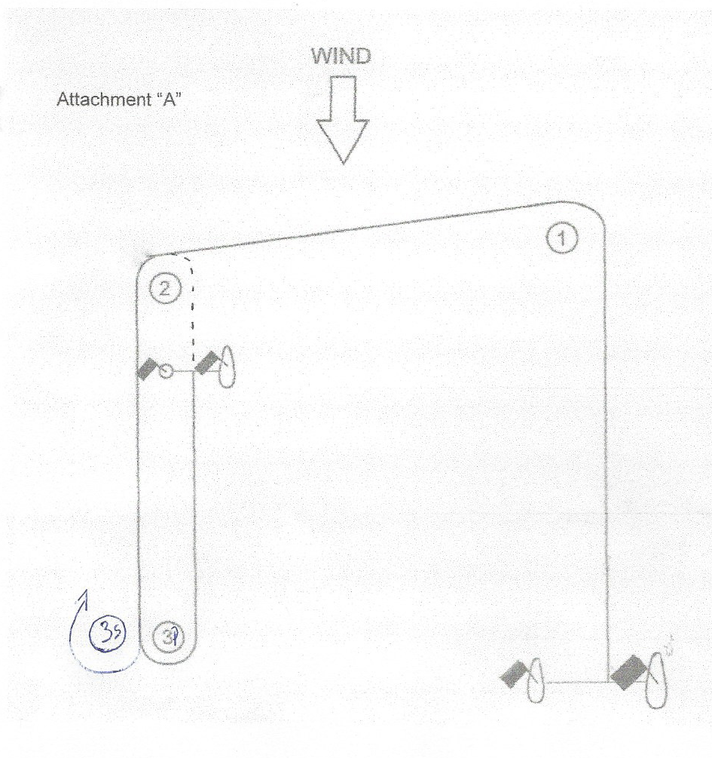

Laser Standard, Laser R , Laser 4.7: Start – 1 – 2 – 3s,3p – 2 – 3s,3p – Cilj
Optimist: Start – 1 – 2 – 3s,3p - Cilj

